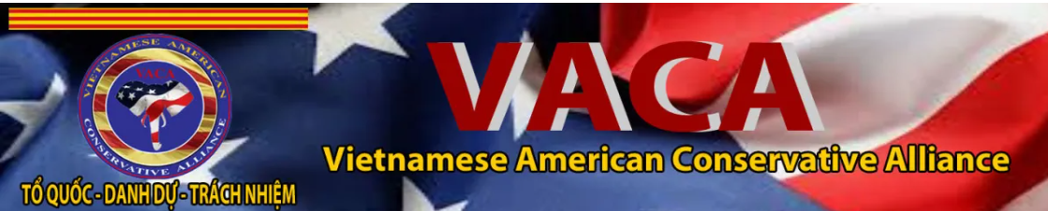
The Vietnamese American Conservative Alliance (VACA) is proud to announce its formal endorsement of Mr. Nick Tran for the United States Congress. After a thorough review of his platform and a deep assessment of his character, we have found that Nick Tran embodies the core values our organization holds sacred: freedom, faith, family, our motto of Country, Honor, Duty, and our love for the USA and her Constitution.

Why Nick Tran Aligns with VACA Principles:
- A Proven Guardian of Freedom: As a combat veteran, Nick has already made the ultimate commitment to defend the U.S. Constitution against all enemies. His dedication to "National Security based on honor and duty" is not a campaign slogan - it is his life’s work.
- Fiscal Responsibility & Free Enterprise: With his background as a business leader, Nick understands that the path to prosperity lies in limiting government overreach and empowering the individual. His pledge to cut waste and shrink the federal bureaucracy directly supports our goal of protecting free enterprise and fair trade.
- A Champion for Family and Faith: Nick’s platform is built on the protection of traditional family values and medical freedom. He understands that the strength of our community comes from the "bottom-up" - from families and communities, not from "handpicked politicians" in Washington.
- Authentic Accountability: In an era of career politicians, Nick’s pledge to serve no more than three terms and his commitment to donate one-third of his salary to veterans’ causes demonstrate the "Sacrifice, Accountability, and Results" that our community demands.
For the Vietnamese American community, the fight against totalitarianism and collectivism is a lived experience. Nick Tran stands as a bulwark against the "extreme socialism" and "indoctrination" that VACA opposes. He represents a new generation of leadership that puts America First while honoring the cultural traditions that make our diaspora strong.
We urge all conservative Vietnamese Americans and allies to support Nick Tran. He is a public servant who remembers what duty means.
//signed//
Dr. Phạm Hiếu Liêm
President of the Vietnamese American Conservative Alliance

